ÁLVARO SIZA ARCHIVE – A SHARED ARCHIVE

Adria Seccareccia, Martien de Vletter
Canadian Centre for Architecture, Canada
ref@cca.qc.ca

Carla Seixas, Eunice Pereira, Mirijam Garcia
Calouste Gulbenkian Foundation - Art Library, Portugal
artlib@gulbenkian.pt

Sónia Oliveira
Serralves Foundation, Portugal
biblioteca@serralves.pt

Abstract
The Álvaro Siza archive documents the architectural work of Portuguese architect Álvaro Siza. The records in this archive relate to Siza’s built and unbuilt projects, dating from 1958 to 2012. The archive will continue to be expanded with projects developed by Siza after 2012. The archive is comprised of drawings, textual documentation, photographic material, electronic records, sketchbooks, and models. A collaborative project was established between the Canadian Centre for Architecture (CCA), Serralves Foundation (SF), and Calouste Gulbenkian Foundation (CGF) to allow for international research about and access to the archive. Each of the three institutions hold records for different architectural projects represented within the archive and collaborate on the descriptive work, while increasing the visibility of the archive. Together, the three institutions work toward making the archive available for researchers and cultural institutions.

Álvaro Siza’s decision to donate his archive to these institutions was made according to best practices for preservation and collection management criteria and, also, with the intent of fostering an inspiring model of collaborative international research, while promoting public awareness of architecture throughout the world.

In 2014, the three institutions initiated this collaborative project, which has since included research, publications, and exhibitions. The primary goal of the project is to encourage discourse at a national and international level regarding the role architecture plays in society.

Keywords: architectural archives, Álvaro Siza, digitisation, preservation, access, description

The donation history
In 2014, Álvaro Siza donated his archive to three institutions—the Calouste Gulbenkian Foundation (CGF) in Lisbon, the Serralves Foundation (SF) in Porto and the Canadian Centre for Architecture (CCA) in Montréal. Álvaro Siza chose these institutions with the intent of selecting the places best suited to the management and preservation of the archive, and also, to foster a new model of collaborative international research and to promote public awareness of architecture in Portugal and throughout the world.

With the donation of his archive, Álvaro Siza expressed the desire “that so many years of work [could] become useful in many ways, as a contribution to research and debate on architecture, particularly in Portugal, and with a perspective opposed to isolation.” As a result of this desire, he communicated his decision to “donate [his archive] to two Portuguese institutions that already [had] the experience, quality, and capacity to develop or enlarge their respective archives (CGF and SF) with the goal of increasing access, dissemination, and active participation in a debate that is no longer simply national nor centred on an individual,” and to “donate to the CCA in Montréal, an institution of unequalled experience and prestige and with a sustained series of activities—exhibitions, publications, research, relations with other related institutions and large visibility. As the CCA is recognized for its experience in the preservation and presentation of international archives, it will care for a large part of my archive and make it accessible, alongside the work of other modern and contemporary architects.”

In the past five years, an exceptional agreement of institutional collaboration and joint commitment was established. Each institution, at its own pace, is aiming to create consistent descriptions and digitisation of the archive to collectively provide access to Siza’s significant body of work, which includes his built and unbuilt projects, dating as far back as 1958. This collaboration is also based on a shared vision and the desire to, in the future, establish standards regarding the archive’s conservation, access, and guidelines for loans. Collaborative projects, such as research, exhibitions, public programs, and publications are also essential to stimulate the national and international discussion about the role that architecture plays in society.

Each of the three institutions holds records for different architectural projects but work together to increase the visibility and accessibility of the archive as a whole. To date, the archive, in its entirety, includes over 65,000 drawings, 500 models, and 394 sketchbooks, as well as project documentation, correspondence, born-digital records, and photographs, negatives, and slides of project sites, construction processes, models, and built projects.

Sharing the archive
As mentioned, one of the primary goals of this collaboration is to provide visibility to the archive, which will include the sharing of a selection of digitised images. This requires an understanding of the search behaviours and needs for researchers at the three institutions, which consist of, but are not limited to, scholars, university students, and curators. Therefore, an understanding of the distinctions between the holdings of each institution is crucial in order to successfully communicate this with researchers.

The objective of this paper is to provide a summarized description of the three parts that each institution holds and to underline the importance of communication between the parties while providing access to and promoting the archive, as well as facilitating the work of researchers. The sharing of the archive is still a work in progress and the main goal is to create, over the years, new or more efficient ways to share the archive between the institutions and with our users.

All three institutions share the same mission, providing access to significant collections and archives. None the less it is important to keep in mind that there are also distinctions, such as choice of standards, policies, backgrounds, institutional identities and histories. These distinctions are reflected in the project.

Calouste Gulbenkian Foundation
The Art Library of the Calouste Gulbenkian Foundation received the first accession at the beginning of 2017. This included records for 38 projects, some relevant projects being the Portugal Pavilion, Expo’98, Terraços de Bragança complex, Santa Maria Church and Parish Centre and the Setúbal College of Education (ESSE).

The Art library also received records for four projects commissioned by the Foundation: the Ballet set for “Quatro Árias de Ópera”; the Gulbenkian Foundation’s stand at the Frankfurt Book Fair; the Gulbenkian Foundation’s stand at the 18th Paris Book Fair; and the Calouste Gulbenkian Foundation Pavilion at the Expolingua Fair.

Since the transfer of this accession, out of the 38 projects, 22 have been digitised and an exhaustive description has been made to allow for a more transparent search for users. Furthermore, thirteen projects have been described and out of these seven have been catalogued to the item level.

Canadian Centre for Architecture
The CCA received the first accession of the archive in 2015. It later received two accessions in 2016 and another accession more recently in March 2019. Materials from the first three accessions have been 90% processed, and consist of approximately 63,000 drawings, 48 linear meters of textual documentation, and 21, 000 photographic materials. Descriptions for these materials are available on the CCA’s website. The 2019 accession as well as the remaining 10% of materials from the first three accessions is still in process and descriptions are being progressively added to the finding aid. Given the volume of the materials and the interest in the archive the CCA made the decision to process the archive in phases and give access to processed portions overtime instead of closing the entirety of the archive until completely processed.

The portion of the archive held at the CCA consists mostly of records for architectural projects of international resonance dating from 1958 to present. Records for architectural projects from 2006 onwards will be held at the CCA. At present, the CCA holds the records for more than 200 architectural projects, as well as 394 of the architect’s sketchbooks.

Serralves Foundation
In the course of its activities, the SF has been investing in the incorporation and valorization of private archives / collections, making them accessible not only from an expositive point of view, integrating cultural programming, but also in a documentary logic, disseminating to specialized audiences, such as students or researchers. Thus, for the SF the acquisition of part of the Siza Archive is framed in this context of the valorization of a rich informational resource of undeniable value, which speaks to the mission of the SF.

The SF holds records for 40 architectural projects (realized and unrealized) which was received by the SF Library in 2015. The projects range from such early works as the Quinta da Conceição swimming pool in Matosinhos (1957-66), developed while working in the studio of architect Fernando Távora, to the Faculty of Architecture of the University of Porto (1979-97) to private houses and of course the Serralves Museum of Contemporary Art.
The following diagram summarizes and identifies the similarities and differences between the three institutions, giving emphasis to communication, access, digitisation, description, arrangement and preservation.

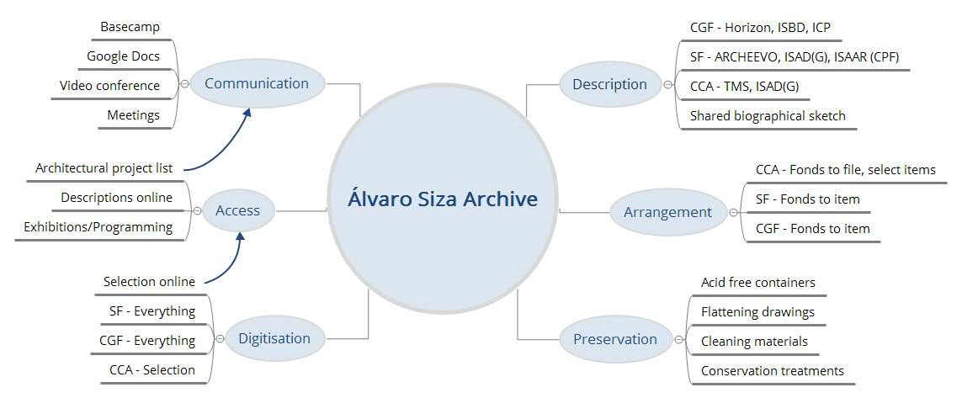
Figure 1 – Diagram of main activities

Communication between the three institutions
Communication is essential for a project of this magnitude. Meetings held before beginning the project and during the donation process where a good starting point to establish common ground. A couple of in person meetings with all three institutions were held in Portugal, however most communication is done via video conferencing and notes, documents, and images, which are shared through Basecamp (figure 2). This way all three institutions stay updated and utilize a platform where all important decisions that concern the archive are discussed.
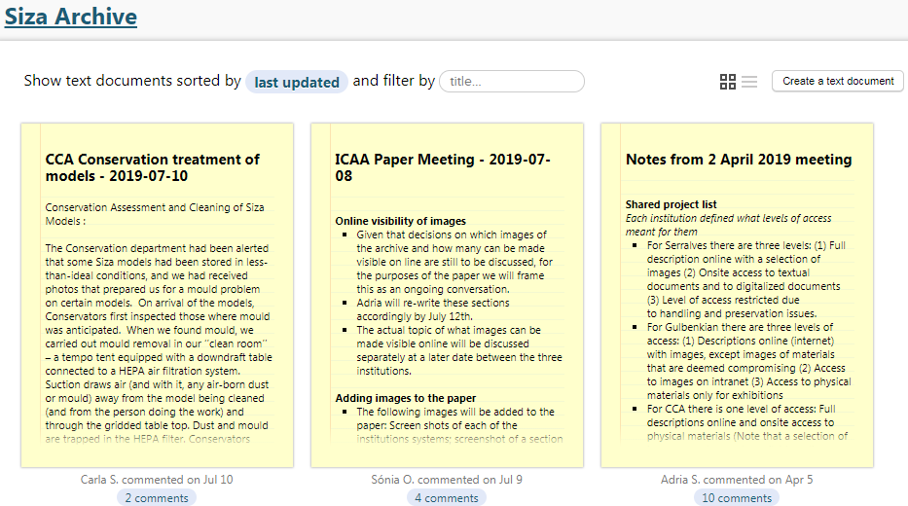
Figure 2 - View of notes in Basecamp

Granted there can be many challenges when communicating over long distances. Video conferencing tools do not always allow for clear communication as connections often break between one or all parties. To overcome this, posting notes on Basecamp following the meeting or simply sending an email listing all decisions made is crucial. This ensures that there were no misunderstandings and if anyone got cut off during the conversation they are able to see what they missed and add any comments they may have regarding the topic discussed. It also helps to remind all of us where we left of in a conversation as there are moments where there are months between each of the meetings.

Another key tool for communication is a shared Google sheet where we list all of the architectural projects for which all three institutions hold records (figure 3). We use the sheet to document: the title of the project; geographic location; English translation of the title; the unique identifier assigned to the project (which each institution creates according to their internal practices); which institution holds records for the identified project; and a column for comments for discussion, which can be used for notes on translations or questions about the project itself. More recently, we also began using this sheet as a tracking document to inform each other which projects have descriptions available online, the level of access available to records for a given project, and if a selection of images are available online.

Figure 3 - Entries in the shared project list

Access to the Álvaro Siza Archive
All three institutions are making or have made their holdings of the archive available for research to scholars and other cultural institutions, as well as other related institutional activities including exhibitions and publications.

The three institutions are dedicated to give online access to a selection of digitised materials, in accordance with their publication and access criteria, onsite access for advanced research, and the donor’s wishes. The Álvaro Siza Archive will be available by appointment for physical consultation in a controlled professional manner at all three institutions. The three institutions reserve the right to control and restrict access to the archive as necessary in relation to internal activities, resources and operations. Access to certain material is restricted due to the stipulations of the donation, or the condition and format of specific archival material. Digital reproductions of the archive are available by request subject to internal review of use, resources, copyright, and any terms stipulated in the donation agreement.

The three institutions will describe or have described their holdings of the archive according to the set of descriptive standards followed within their respective institutions. Once completed, each institution will post the descriptions for their holdings on their website. The drawback of this model is that the researcher will be required to know which of the three institutions hold what set of records in order to find the descriptions they are looking for. To overcome this, in the future, each institution will make available the shared project list so that researchers know which institution holds the set of records they are interested in. Furthermore, the biographical sketch will be the same in the finding aids of all three institutions as well as a portion of the scope and content note.

Architectural project titles
Standardizing the titles of the architectural projects will be a key component to increasing the searchability of the archive. Using the shared project list, previously mentioned, the researcher will know what terms to use when searching on each of the institutions websites and how to refer to projects.

Many of the conversations between the three institutions are on the translation of the architectural projects’ titles. Translation is always a time-consuming process as well as a challenge to ensure that the intention of a title is captured in the translation. In this case, with the involvement of three different institutions achieving a consensus is also required. All three institutions are working together to create the most accurate translations for the architectural projects represented in the archive. The shared project list serves as a useful tool to discuss suggested translations.

Furthermore, video conference and in person meetings were crucial in reaching a consensus regarding assigning titles, identifying geographic locations in titles, and formatting titles. More importantly is documenting these decisions. Since the project spans over years staff members from the three institutions have changed overtime. To overcome this, instead of simply documenting decisions or notes from meetings through emails we use our shared account on Basecamp, where, for instance, are the notes from a 2016 meeting held at Serralves that outlined guidelines regarding project titles.

Arrangement and description of the material
Since each institution uses different systems and descriptive and metadata standards, each institution described the materials and created finding aids according to their internal practices and needs. Furthermore, each institution does not describe to the same level of description.

Anteceding the description process the Art Library maintained the order in which the archive arrived after leaving the Álvaro Siza office. The following steps for each document are the archival inventory, the attribution of a sequential identifier, that identifies all documents that are part of the same project, and of a call number that permits the localization of each document in the separate storage units.

The standards used by the Art Library (CGF) are the Resource Description Format Unimarc, the International Standard Bibliographic Description (ISBD), the Anglo-American Cataloguing Rules, the Statement of International Cataloguing Principles (ICP) and the Portuguese Cataloguing Rules. They also developed a specific policy for describing the Álvaro Siza Archive to establish criteria and procedures for the accurate description of these architectural projects. This policy was based on the standards in use already mentioned, other architectural archives descriptive policies applied in the past, the particularities of the archive at hand, as well as the intent to integrate descriptive criteria used by the CCA and the SF.

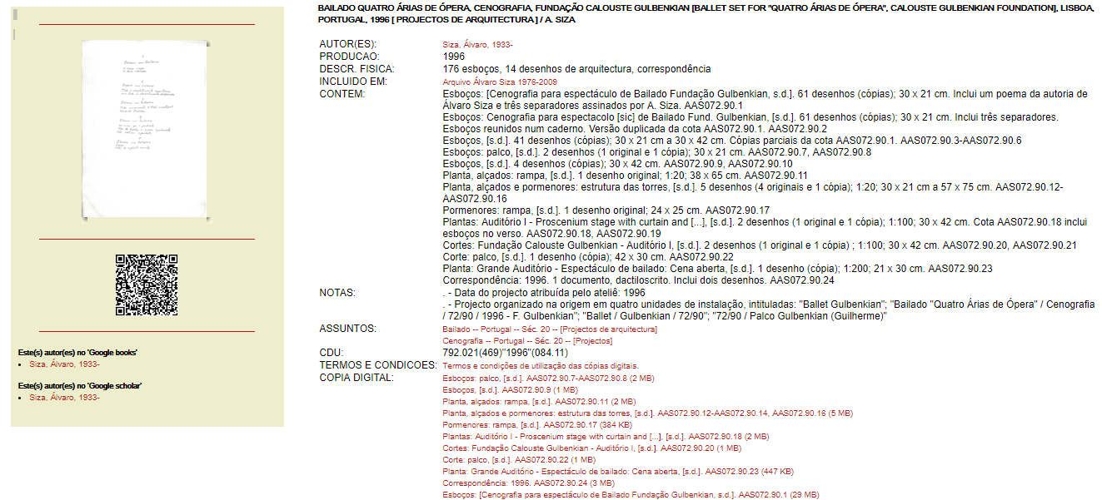
In their Integrated Library System, the Art Library (CGF) created a record for the Archive and dependent/subordinated individual records for each project, which include descriptions in separate UNIMARC fields for each document or group of documents (e.g. drawings that correspond to the same project phase). Each of these fields will have the corresponding digitized images of the materials, and a selection will be visible in their Online Catalogue.
Figure 4 - Record of a project (CGF)

Described in the database ARCHEEVO, SF, achieved physical and intellectual control, capturing each of the activities represented, the diversity of supports and space the materials occupy. By studying the physical arrangement they were generally able to organize the records, anticipating the classification and archival description. It was also important to note when there were electronic documents (studies, drawings, CDs) as a complement to the documentary process and how they can be integrated into the archive. Research, incorporation and analysis were the following steps of the plan, in accordance with international standards - ISAD (G) and ISAAR (CPF) -, and with the guidance of the Directorate General of Archives (ODA). The classification, crucial for capturing the arrangement, was also created in accordance with archival principles.
Although the SF has not completely described the entirety of the documentation, the initial projects are fully described to the item level. Small projects will be done like this, larger projects will be described to the file level (figure 5).
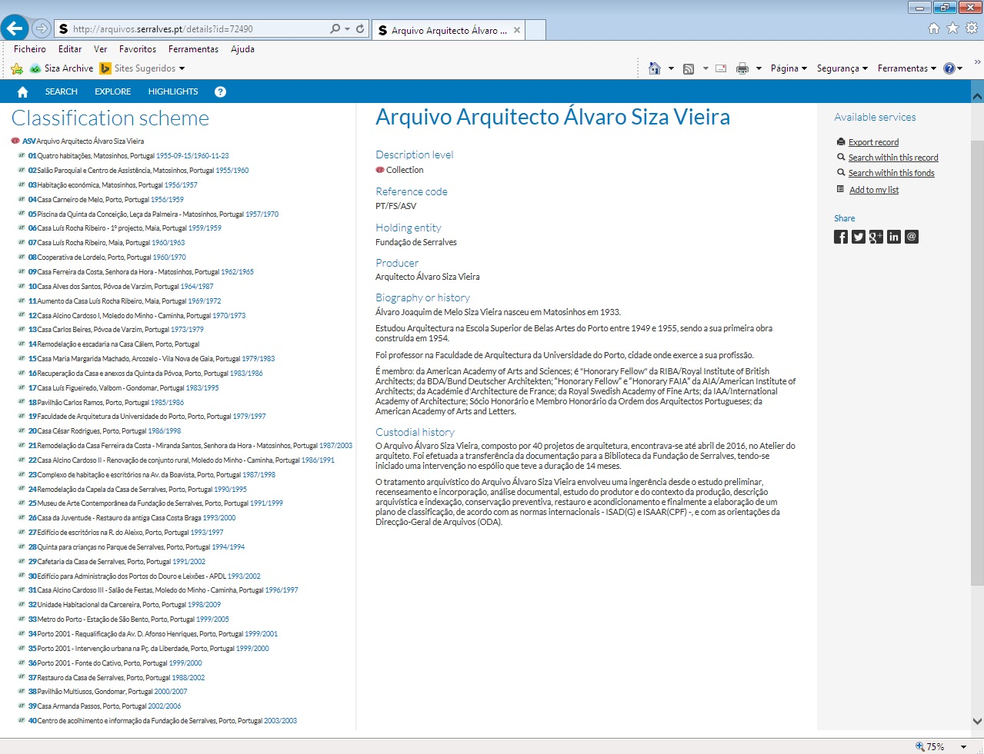
Figure 5 - Description and arrangement of archive (SF)

The CCA uses the archival descriptive standard ISAD(G) to describe all archives in its holdings, including the Álvaro Siza Archive. Records in this archive held by the CCA were described to the file level, with the bulk of the materials arranged in the Architectural Projects Series. Similarly to the other two institutions, the CCA arranged materials within this series into separate sub-series, with each sub-series representing a set of records for a specific project. This arrangement respects the order in which the office organized most of the materials and was the way materials were sent from Siza’s office. The CCA describes its archives in The Museum System (TMS), which is a collection management system. A challenge of using TMS is the inability for the system to generate finding aids. Therefore the CCA developed an in house interface (figure 6) for finding aids available on the CCA’s website which allows researchers to navigate across different levels of a finding aid’s hierarchy.

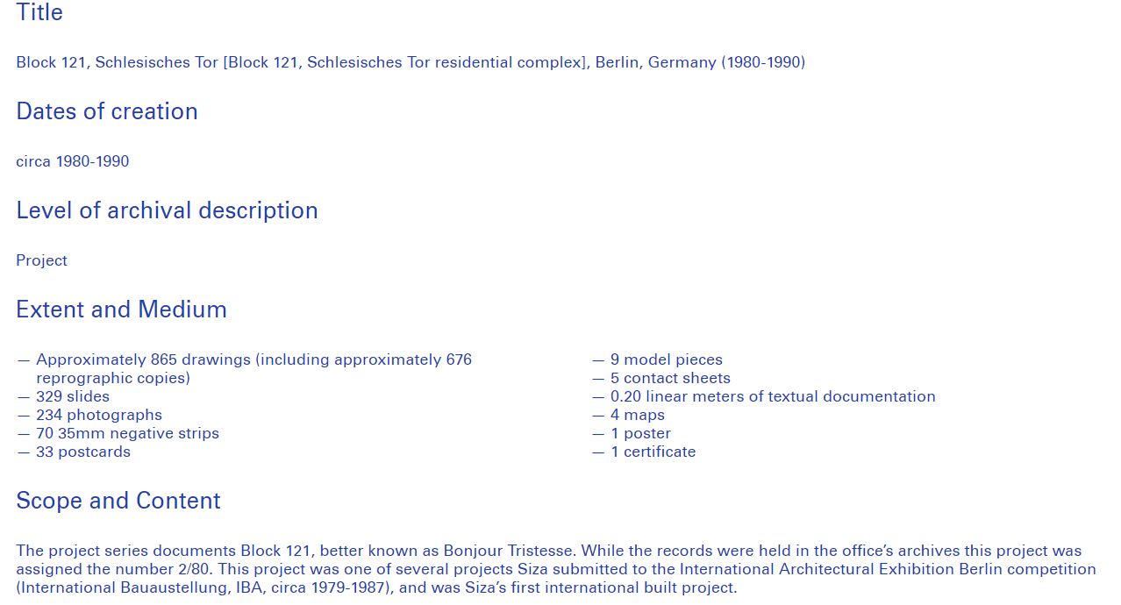
Figure 6 - Portion of a subseries description in the finding aid (CCA)

Digitisation
Each institution approaches the digitistion of the archive differently. Reasons for why or why not to digitise materials can depend on various factors such as financial resources, requests, institutional projects, preservation, institutional projects, etc. In some cases all the materials received have been or are being digitised and in other cases digitisation is carried out upon request and for research purposes.

Although several materials are and have been digitised, selecting which of these digitised images are made visible online is in the process of being discussed. To date the SF digitised the entirety of the records in its holdings that amount to over 40 thousand images, the CCA has digitised a selection of 311 materials through its Find and Tell program for which an invited resident makes a selection from an assigned archive, and the Art Library (CGF) is digitising the entirety of the archive. The guidelines for the selection criteria for which images will be available online will ensure that the donor’s wishes and institutional practices are respected. Furthermore, other considerations taken into account when giving online access to these images will include limiting handling of fragile materials and the nature of the information, for instance potentially sensitive client information.

Preservation
The institutions will also preserve and maintain the archive in accordance with archival best practices. The goal is to preserve the archive for the purposes of posterity. As such, we are dedicated to preserving that archive’s informational value, its historical context, and evidentiary value, as well as preserve its original order and provenance, while documenting the artefactual value of the materials.
Conservation treatments and preservation decisions are primarily undertaken to prevent further deterioration of the material. Digitization in many cases is used as a way to limit handling of fragile materials. The archive was mostly removed from original containers and rehoused in new acid free containers and folders. In most cases, drawings are stored flat and were physically and chemically stabilized, for instance tears and detached pieces were repaired and dirt was removed. Drawings are in indian ink, graphite pencil, colored pencils, or ink on either tracing paper, opaque paper or plastic. Therefore, depending on the type of architectural drawing (nature/process of the drawing), interleave was used between drawings to prevent damage to other types of materials. The archive is stored in acclimatized vaults with conditions that are optimal for storing paper. Materials are stored according to size and format, while larger drawings are stored in horizontal drawers or oversized boxes smaller formats, such as correspondence, are stored on shelves designed for textual boxes (figure 7).

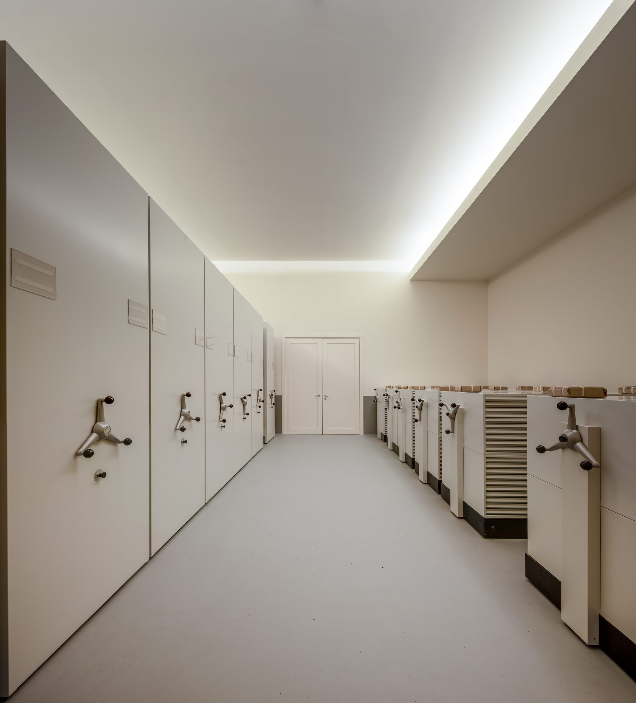
Figure 7 - Architectural storage archive (SF)

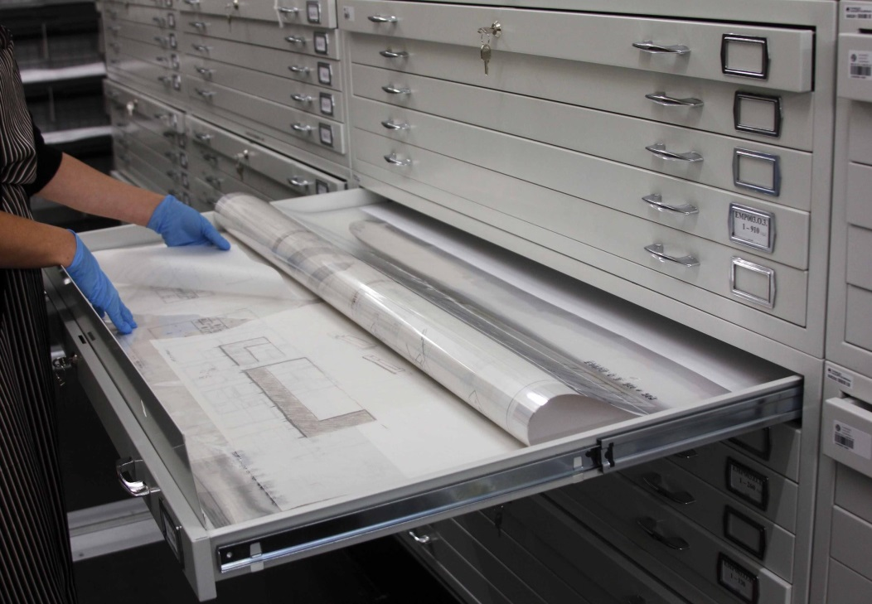
Figure 8 - Horizontal storage (CGF)

In general materials were in good condition upon receiving the archive. However, certain materials received a CO2 or anoxia with nitrogen source treatment due to the presence of insects and the models, mostly those made of cardboard, paperboard or coated foam, had developed mold over the years while in storage. The architect’s office provided photographs of the models and indicated with stickers which models to take precautions with. Therefore, conservators were able to remove these from the rest of the collection and either chemically clean models with biological contamination while dry cleaning others. Given the volume of models it was important to understand which of the models posed a risk to other collection materials and which were stable. By using a Lumitester, a method shared by the Canadian Conservation Institute, levels of contamination for some of the models were tested to make an assessment of which models posed a risk to other collection materials.

Conclusion
As a model for encouraging collaborative international research, the donation of this archive to three institutions has been successful. There have already been exhibitions, conversations with scholars, and lectures that the three institutions participated in some way to highlight this archive. We also update each other regarding research requests or exhibitions and programming that utilize the archive. Perhaps the success has been in part due to the fact that the commitment to collaborate was integral to the donation process from the beginning as opposed to the archive being split and donated to different institutions over a period of time. All three institutions took part in the donation process together, from the first conversations with the donor and creating the deed of gift to the press release on the acquisition and then processing and making the archive accessible.

Although communication over large geographic distances has been a challenge in some instances, because the archive is held in three different geographic locations as well as the fact that there are some differences in research groups between the three institutions, public awareness of the archive has had a much broader reach.

Varying institutional practices can also be a challenge because descriptive practices and the level of the description may vary, as well as access policies to the physical and digital material are different from institution to institution, which require that users adapt to these differences.

It is safe to say that this has been a challenging but, at the same time, rewarding experience for the three institutions. The challenge is the need for continuous communication, and to develop shared guidelines, common projects and creative ways of sharing and promoting the archive to benefit our users across the world. The rewarding aspect of this collaboration is the sharing of experiences and the gratification of working with other professionals towards the same goals with the same interests in mind. This inevitably leads to a shared knowledge of the archive between much larger groups of people. Furthermore, the project benefits from the diversity of professional backgrounds and institutional perspectives. There is still much work to be done, the archive is in many ways a living organism and projects developed after 2012 will need to be integrated into the archive. The present and future goal is to encourage discourse at a national and international level regarding the role that architecture plays in society and the importance of the Álvaro Siza Archive in this context.

The architect Álvaro Siza initiated this project and brought these three institutions together to contribute to the vast field of architectural knowledge. The role of the three institutions is to make sure that his legacy receives international recognition and is given a voice in the history of architecture.

“Álvaro Siza doa acervo à Gulbenkian, Serralves e ao Centro Canadiano de Arquitectura,” Jornal Público (2014). Accessed July 30, 2019, https://www.publico.pt/2014/07/23/culturaipsilon/noticia/siza-vieira-doa-acervo-a-gulbenkian-serralves-e-ao-centro-canadiano-de-arquitetura-1664010.
A Project Management and Team Communication Software, https://basecamp.com/
Photograph by Fernando Guerra | FG+SG
Photograph by Catarina Garrido and Helena Gonçalves.
With contributions from Constança Costa Rosa and Sónia Casquiço (CGF), as well as Karen Potje and David Stevenson (CCA)

